

IMPLEMENTATION OF SMART SYSTEM IN PARKING

**Abstract:**

In today’s era one of the most common problems which the world is facing is an exponential increase in population. This has indirectly increased a lot of other issues; one of them being the quantity of vehicles on the road. The increased number of vehicles results in shortage of parking areas. This project aims to present an intelligent parking system for vehicles that identifies the parking slot automatically through sensors and displays it without making the drivers to circle around the parking area. The availability of parking slots will be displayed to the drivers at the entrance. It also captures the number plate of vehicles by using camera and recognises the number using image processing and stores it in the server at the entrance and also at the exit of parking area for ease of payment purposes. All the information’s will be simultaneously updated in the IoT server and can be used for future use. It is found that the system decreases the manual work and provides high efficiency and high accuracy.

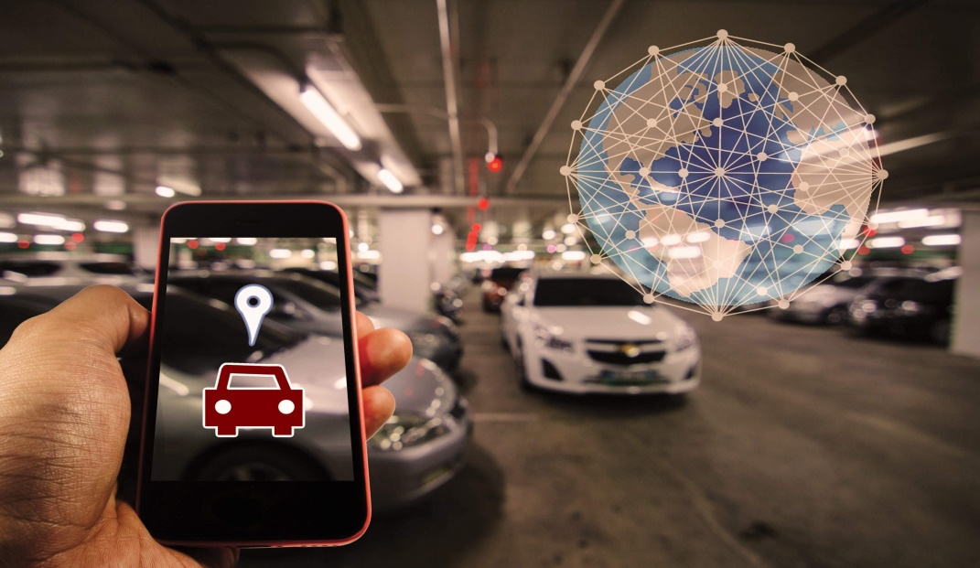

**INTRODUCTION**

In past days individuals use the general public mode of transportation as Bus and Train for moving from one place to a different. But because of globalization the individuals move from geographical area to urban areas for employment and different wants the Individual transportation are improved plenty ease. Owing to these increase in vehicle the parking become very complicated and the people can park their on the either sides of the roads results in heavy traffic. At present there's no systematic approach. The manual management may be enforced in many areas. The parking problem in big cities, especially the mega-cities, has become one of the key causes of the town holdup, driver frustration and air pollution. The need for parking and parking facilities is constantly on the rise. On average, 30 percent of traffic is caused by drivers wandering around parking spaces. This paper shows a intelligent and user friendly automated parking system.



**EXISTING SYSTEM :**

In parking area, the customer enters into parking area to park their vehicles. The existing system to park the vehicles is not well organized. Everything in the existing system is manually managed. As when the drivers enter the parking area they have to search around for vacant spaces to park their vehicles. The concerned work cheers for the availability of slots for the vehicle. This process involves multiple chains of asking co-workers at different slots. If there is no slot available to park they have to go back and search for slot in some other parking area. This majorly causes difficulty and frustration to the drivers which leads to congestion in parking area and due to this emission from vehicles is majorly increased. The data and records are being manually organized. Thus to overcome from the above stated problems and also to reduce the man power we introduce a proposed system.

**SOFTWARE REQUIREMENTS**

To implement a parking slot booking system, a comprehensive set of software requirements is essential for the development and operation of both the frontend and backend components. On the backend, a suitable programming language, such as Node.js, Python, Java, or Ruby, should be selected along with a web framework for efficient development. A robust database management system (DBMS) like MySQL, PostgreSQL, or MongoDB is needed to store user data, parking lot information, and reservations. The development of RESTful APIs is crucial to facilitate communication between the frontend and backend.

On the frontend, HTML, CSS, and JavaScript serve as fundamental technologies, and a frontend framework such as React.js, Angular, or Vue.js can be chosen for organized and efficient development. User interface (UI) libraries like Bootstrap or Materialize CSS enhance the overall design and responsiveness. An HTTP server, such as Nginx or Apache, should be set up to handle frontend requests and API communication.

On the frontend, HTML, CSS, and JavaScript serve as fundamental technologies, and a frontend framework such as React.js, Angular, or Vue.js can be chosen for organized and efficient development. User interface (UI) libraries like Bootstrap or Materialize CSS enhance the overall design and responsiveness. An HTTP server, such as Nginx or Apache, should be set up to handle frontend requests and API communication.

For payment integration, third-party services like Stripe, PayPal, or Braintree can be integrated. Communication tools, including email/SMS services like SendGrid or Twilio, facilitate confirmation notifications. An integrated development environment (IDE) such as Visual Studio Code or PyCharm, along with a package manager like NPM, streamlines the development process. Testing frameworks like Jest, Pytest, or JUnit, along with CI tools like Jenkins or Travis CI, ensure code quality. Documentation tools like Swagger/OpenAPI or Postman assist in documenting code and APIs. Optionally, an admin panel framework like Django Admin or Forest Admin may be employed for backend data management. Collaboration tools such as Slack, Jira, or Trello support team communication and project management. This comprehensive set of software requirements forms the foundation for the development and successful deployment of a parking slot booking system.